Partial / residual correlation: AUDUSD and USDCHF
Method 07 / daily log returns / leave-currency-out USD factor / Alpari D1 full available history

Study setup
Logical pair: AUDUSD , USDCHF
Broker symbols: AUDUSD_i , USDCHF_i
Snapshot: 2026-11-03_majors_alpari_D1
Timeframe: D1
Matched return window: 1999-01-05 to 2026-11-02 (UTC bar dates)
Matched return count n: 7148
Dropped unfinished last bar dated 2026-11-03 UTC after a tick-volume check against the prior complete day.
USD-strength sign rule: minus log return when USD is the quote (EURUSD, GBPUSD, AUDUSD, NZDUSD); plus log return when USD is the base (USDJPY, USDCHF, USDCAD). EURGBP is never a constituent.
Control z constituents (5): EURUSD, GBPUSD, NZDUSD, USDJPY, USDCAD
z_t = equal-weight mean of those USD-strength returns on the same day
Complete matched rows (Excel): AUDUSD-USDCHF_Partial_D1.xlsx
Complete matched rows (HTML table): AUDUSD-USDCHF_Partial_D1_data.html

Method carried forward
Partial / residual correlation regresses each matched daily log return of close, ln(close_t / close_t-1), on the same leave-currency-out USD strength factor z, then takes Pearson correlation of the two residual series. Quotes are not inverted. z is the equal-weight mean of USD-strength returns from other majors that do not share a non-USD currency with either leg; EURGBP is never a constituent. USD-strength is minus the log return when USD is the quote (EURUSD, GBPUSD, AUDUSD, NZDUSD) and plus the log return when USD is the base (USDJPY, USDCHF, USDCAD). OLS uses an intercept on each leg. rho_partial is symmetric under swap of the two symbols. It describes leftover linear co-movement after removing linear z; it is not a cause, not a lead, and not a trading signal. Daily rows are not independent and residuals are estimated, so the two-sided p-value and Fisher interval are secondary. Same-sample raw Pearson r is a side check only.

Regression on z
leg | intercept_a_or_c | slope_b_or_d | R2
AUDUSD | 4.292e-05 | -1.3084751 | 0.57165568
USDCHF | -7.793e-05 | 0.97864991 | 0.41928984

Results
rho_partial: 0.219052
Two-sided p-value: 2.13614e-78
Approximate 95% Fisher interval: [0.196868, 0.241011]
Same-sample raw Pearson r: -0.380331
rho_partial minus r: 0.599382

Conclusion
Over 7148 matched daily rows for AUDUSD and USDCHF after removing a leave-currency-out USD factor built from 5 constituents, rho_partial is 0.2191 (positive, weak residual linear link in this sample). Approximate 95% Fisher interval: [0.1969, 0.2410]. Same-sample raw Pearson r is -0.3803 (partial minus r = 0.5994). Leg R-squared on z: AUDUSD=0.5717, USDCHF=0.4193. Two-sided p under the usual independent-pairs model is 2.136e-78; residuals are estimated and daily FX rows are linked, so treat p as secondary. This does not establish cause, lead-lag, or a lasting trading rule.

Charts
Daily closes
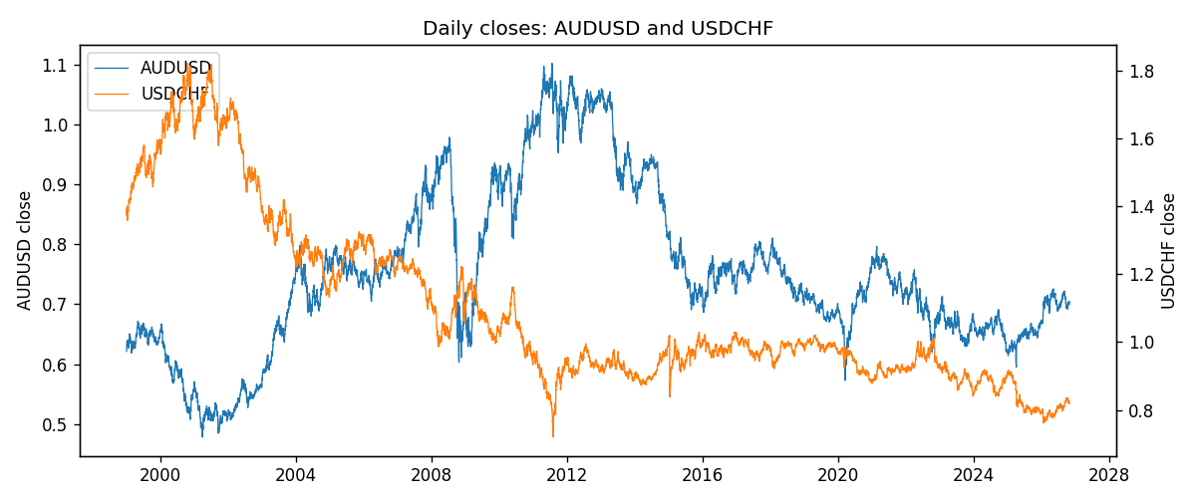
Log returns and control z
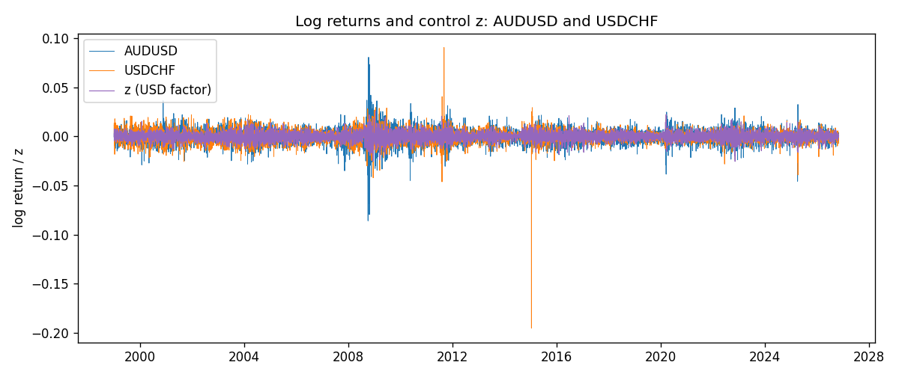
Residual scatter e_x vs e_y
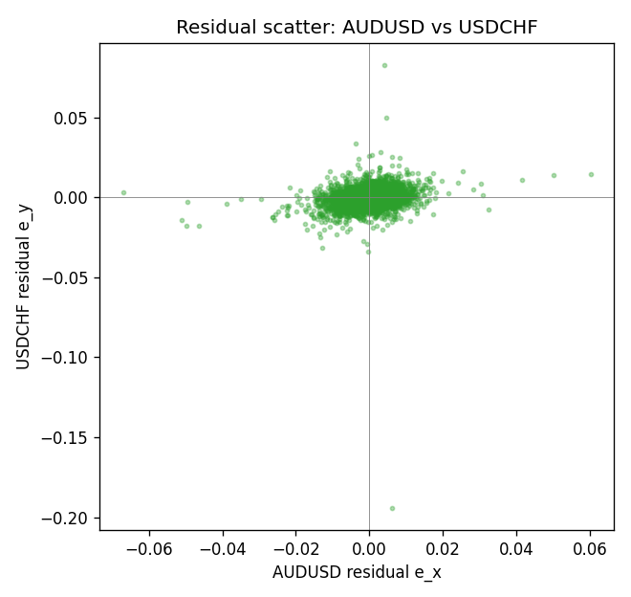

Data report
Every matched row that entered the partial correlation is stored in the sibling Excel workbook named AUDUSD-USDCHF_Partial_D1.xlsx. That file is the complete data archive for redrawing charts. Embedding all rows as a Word table is impractical at this length; the Word file holds the column list, column summaries, and the first and last 15 matched rows.
Columns: time, AUDUSD_open, USDCHF_open, AUDUSD_high, USDCHF_high, AUDUSD_low, USDCHF_low, AUDUSD_close, USDCHF_close, AUDUSD_tick_volume, USDCHF_tick_volume, AUDUSD_spread, USDCHF_spread, AUDUSD_real_volume, USDCHF_real_volume, AUDUSD_log_return, USDCHF_log_return, usd_strength_EURUSD, usd_strength_GBPUSD, usd_strength_NZDUSD, usd_strength_USDJPY, usd_strength_USDCAD, z, AUDUSD_fitted, USDCHF_fitted, AUDUSD_resid, USDCHF_resid
Column summaries (matched calculation rows)
column | count | mean | std | min | 25% | 50% | 75% | max
AUDUSD_open | 7148 | 0.75254463 | 0.13531821 | 0.4785 | 0.661255 | 0.7317 | 0.812135 | 1.10284
USDCHF_open | 7148 | 1.0960885 | 0.25173228 | 0.72022 | 0.9203525 | 0.9894 | 1.2355 | 1.8219
AUDUSD_high | 7148 | 0.75660194 | 0.1358782 | 0.4878 | 0.6652025 | 0.7351 | 0.8182725 | 1.10795
USDCHF_high | 7148 | 1.101368 | 0.25346299 | 0.73305 | 0.9245 | 0.993025 | 1.240225 | 1.8313
AUDUSD_low | 7148 | 0.74848743 | 0.13462984 | 0.4775 | 0.65803 | 0.727775 | 0.80652 | 1.0975
USDCHF_low | 7148 | 1.0909798 | 0.25015306 | 0.08565 | 0.9169075 | 0.98582 | 1.229425 | 1.8121
AUDUSD_close | 7148 | 0.75259994 | 0.13529833 | 0.4786 | 0.6614925 | 0.7318 | 0.81193 | 1.10169
USDCHF_close | 7148 | 1.0960817 | 0.25162815 | 0.72025 | 0.92048 | 0.989445 | 1.2352 | 1.8217
AUDUSD_tick_volume | 7148 | 77889.255 | 138502.92 | 109 | 5574 | 43696 | 71619 | 1234623
USDCHF_tick_volume | 7148 | 74666.538 | 113693.11 | 350 | 12884 | 40421 | 70666.5 | 858589
AUDUSD_spread | 7148 | 30.707051 | 16.89031 | 0 | 13 | 30 | 50 | 50
USDCHF_spread | 7148 | 25.894096 | 24.64185 | 0 | 5 | 16 | 50 | 100
AUDUSD_real_volume | 7148 | 5.2809589e+09 | 1.2584371e+11 | 0 | 0 | 0 | 0 | 3.811512e+12
USDCHF_real_volume | 7148 | 2.3408849e+10 | 8.9348471e+10 | 0 | 0 | 0 | 0 | 1.9331921e+12
AUDUSD_log_return | 7148 | 3.157e-05 | 0.00755018 | -0.08602525 | -0.00385014 | 0.00029168 | 0.00415111 | 0.0806166
USDCHF_log_return | 7148 | -6.945e-05 | 0.0065937 | -0.19545699 | -0.00334697 | 8.15e-05 | 0.00331954 | 0.09051364
usd_strength_EURUSD | 7148 | 2.16e-06 | 0.0058013 | -0.03433183 | -0.00325609 | -0 | 0.00324218 | 0.03123819
usd_strength_GBPUSD | 7148 | 1.992e-05 | 0.00564699 | -0.03112653 | -0.00318167 | -3.426e-05 | 0.0031217 | 0.08388241
usd_strength_NZDUSD | 7148 | -1.914e-05 | 0.00764519 | -0.05966839 | -0.004586 | -0.00023666 | 0.00424201 | 0.07027433
usd_strength_USDJPY | 7148 | 5.267e-05 | 0.00620906 | -0.03908203 | -0.00319392 | 0.00012736 | 0.00340928 | 0.05184024
usd_strength_USDCAD | 7148 | -1.226e-05 | 0.00514518 | -0.03859748 | -0.00283513 | 4.873e-05 | 0.00272781 | 0.03436319
z | 7148 | 8.67e-06 | 0.00436274 | -0.0255108 | -0.00249808 | 1.679e-05 | 0.00252747 | 0.02605376
AUDUSD_fitted | 7148 | 3.157e-05 | 0.00570853 | -0.03404778 | -0.00326422 | 2.094e-05 | 0.00331159 | 0.03342316
USDCHF_fitted | 7148 | -6.945e-05 | 0.00426959 | -0.02504408 | -0.00252268 | -6.15e-05 | 0.00239557 | 0.02541958
AUDUSD_resid | 7148 | -0 | 0.00494144 | -0.06704333 | -0.0023664 | 0.00013788 | 0.00254128 | 0.06019429
USDCHF_resid | 7148 | -0 | 0.00502469 | -0.19413295 | -0.00226231 | 0.00013292 | 0.00236925 | 0.08281588
First 15 matched rows (selected columns)
time | AUDUSD_close | USDCHF_close | AUDUSD_log_return | USDCHF_log_return | z | AUDUSD_fitted | USDCHF_fitted | AUDUSD_resid | USDCHF_resid
1999-01-05 | 0.6215 | 1.3724 | -0.00080418179 | 0.0039424743 | -0.00014357915 | 0.00023078659 | -0.00021844859 | -0.0010349684 | 0.0041609228
1999-01-06 | 0.6289 | 1.3912 | 0.011836351 | 0.013605652 | 0.0034684532 | -0.0044954679 | 0.0033164666 | 0.016331819 | 0.010289185
1999-01-07 | 0.6345 | 1.3782 | 0.0088650256 | -0.0093883841 | -0.004627409 | 0.0060977664 | -0.0046065483 | 0.0027672592 | -0.0047818358
1999-01-08 | 0.6347 | 1.3935 | 0.00031515916 | 0.011040268 | 0.002106135 | -0.0027129084 | 0.0019832339 | 0.0030280675 | 0.0090570341
1999-01-11 | 0.6393 | 1.4009 | 0.0072213815 | 0.0052963193 | -0.003442241 | 0.0045470035 | -0.0034466837 | 0.002674378 | 0.0087430029
1999-01-12 | 0.6362 | 1.3872 | -0.0048608485 | -0.0098275602 | 0.0074939024 | -0.009762668 | 0.0072559721 | 0.0049018195 | -0.017083532
1999-01-13 | 0.6312 | 1.3621 | -0.0078902098 | -0.018259701 | 0.00053503526 | -0.00065716348 | 0.00044567735 | -0.0072330463 | -0.018705378
1999-01-14 | 0.6295 | 1.3588 | -0.002696916 | -0.0024256692 | 0.0010371342 | -0.0013141474 | 0.0009370564 | -0.0013827686 | -0.0033627256
1999-01-15 | 0.634 | 1.3834 | 0.007123101 | 0.01794228 | 0.0024991561 | -0.0032271667 | 0.002367864 | 0.010350268 | 0.015574416
1999-01-18 | 0.6346 | 1.379 | 0.00094592471 | -0.0031856384 | -0.00038122316 | 0.00054173786 | -0.00045101887 | 0.00040418685 | -0.0027346195
1999-01-19 | 0.6392 | 1.3789 | 0.0072225153 | -7.2518946e-05 | -0.001287075 | 0.0017270224 | -0.0013375307 | 0.0054954929 | 0.0012650117
1999-01-20 | 0.64 | 1.3889 | 0.0012507819 | 0.0072259871 | -0.0014665476 | 0.0019618578 | -0.0015131715 | -0.00071107592 | 0.0087391586
1999-01-21 | 0.6405 | 1.3836 | 0.00078094498 | -0.0038232689 | -0.0012104419 | 0.00162675 | -0.0012625337 | -0.00084580497 | -0.0025607351
1999-01-22 | 0.6327 | 1.3834 | -0.012252745 | -0.0001445609 | 0.0038656144 | -0.0050151434 | 0.0037051483 | -0.0072376018 | -0.0038497092
1999-01-25 | 0.6302 | 1.3868 | -0.0039591468 | 0.0024546976 | -0.00022692939 | 0.00033984831 | -0.0003000193 | -0.0042989951 | 0.0027547169
Last 15 matched rows (selected columns)
time | AUDUSD_close | USDCHF_close | AUDUSD_log_return | USDCHF_log_return | z | AUDUSD_fitted | USDCHF_fitted | AUDUSD_resid | USDCHF_resid
2026-10-13 | 0.69821 | 0.83244 | 0.0035007712 | -0.0024955621 | -0.0037298384 | 0.0049233176 | -0.0037281409 | -0.0014225464 | 0.0012325788
2026-10-14 | 0.69715 | 0.83489 | -0.0015193215 | 0.0029388325 | 0.0027999234 | -0.0036207132 | 0.0026622099 | 0.0021013918 | 0.00027662255
2026-10-15 | 0.69191 | 0.82676 | -0.0075447063 | -0.0097855323 | -0.0044858039 | 0.0059124796 | -0.0044679664 | -0.013457186 | -0.0053175659
2026-10-16 | 0.69426 | 0.82377 | 0.0033906408 | -0.0036230826 | -0.0030187525 | 0.0039928794 | -0.0030322368 | -0.00060223867 | -0.00059084584
2026-10-19 | 0.6978 | 0.82677 | 0.0050859986 | 0.0036351779 | 0.00080178649 | -0.0010062008 | 0.00070673341 | 0.0060921995 | 0.0029284445
2026-10-20 | 0.70022 | 0.8246 | 0.0034620426 | -0.0026281224 | -0.0035323421 | 0.0046648986 | -0.0035348612 | -0.001202856 | 0.00090673877
2026-10-21 | 0.70275 | 0.82427 | 0.0036066384 | -0.00040027413 | -0.0010390503 | 0.0014024884 | -0.0010948014 | 0.00220415 | 0.00069452726
2026-10-22 | 0.70186 | 0.82032 | -0.0012672558 | -0.0048036381 | -0.0013100943 | 0.0017571426 | -0.0013600585 | -0.0030243984 | -0.0034435796
2026-10-23 | 0.70353 | 0.82497 | 0.0023765656 | 0.005652514 | 0.00014791793 | -0.00015063009 | 6.6825007e-05 | 0.0025271957 | 0.005585689
2026-10-26 | 0.70128 | 0.82649 | -0.0032032829 | 0.0018407959 | 0.0023570193 | -0.0030411842 | 0.0022287618 | -0.00016209868 | -0.0003879659
2026-10-27 | 0.70245 | 0.82865 | 0.0016669876 | 0.0026100526 | 0.0024168583 | -0.0031194821 | 0.0022873233 | 0.0047864697 | 0.00032272932
2026-10-28 | 0.70533 | 0.82781 | 0.0040915541 | -0.0010142111 | 0.00022603904 | -0.00025284961 | 0.00014327822 | 0.0043444037 | -0.0011574893
2026-10-29 | 0.70245 | 0.82379 | -0.0040915541 | -0.0048680164 | -0.0013924077 | 0.0018648477 | -0.0014406146 | -0.0059564018 | -0.0034274018
2026-10-30 | 0.70316 | 0.82438 | 0.0010102376 | 0.00071594559 | -0.00049682284 | 0.00069299717 | -0.00056415049 | 0.00031724046 | 0.0012800961
2026-11-02 | 0.69971 | 0.81851 | -0.0049184984 | -0.0071459744 | 0.0005275288 | -0.00064734145 | 0.00043833114 | -0.004271157 | -0.0075843056

